Initial schemas of tables:
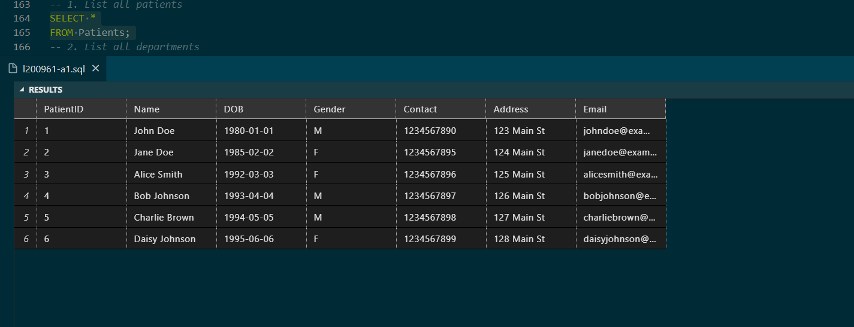
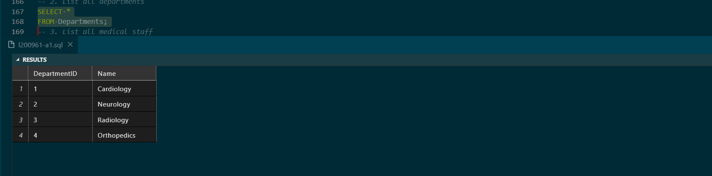
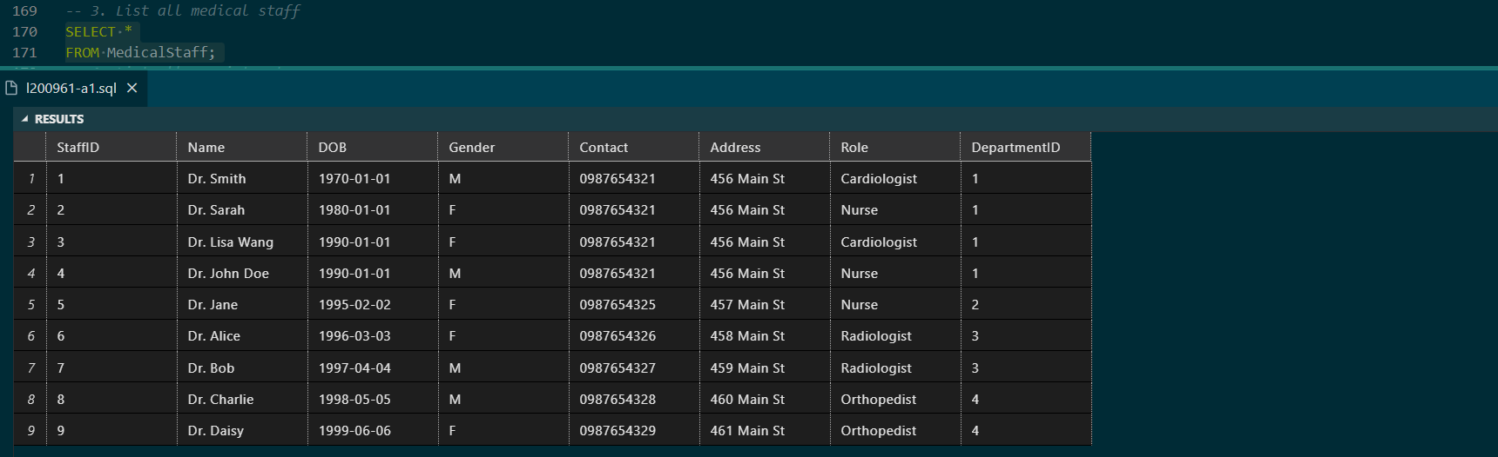

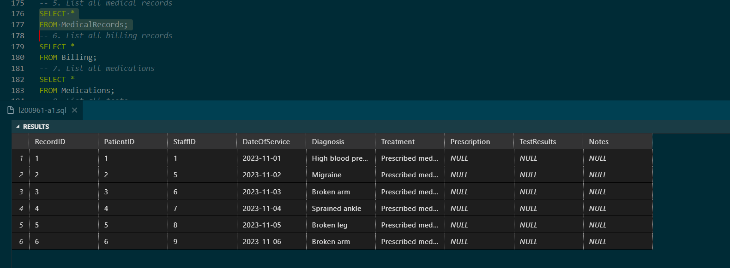
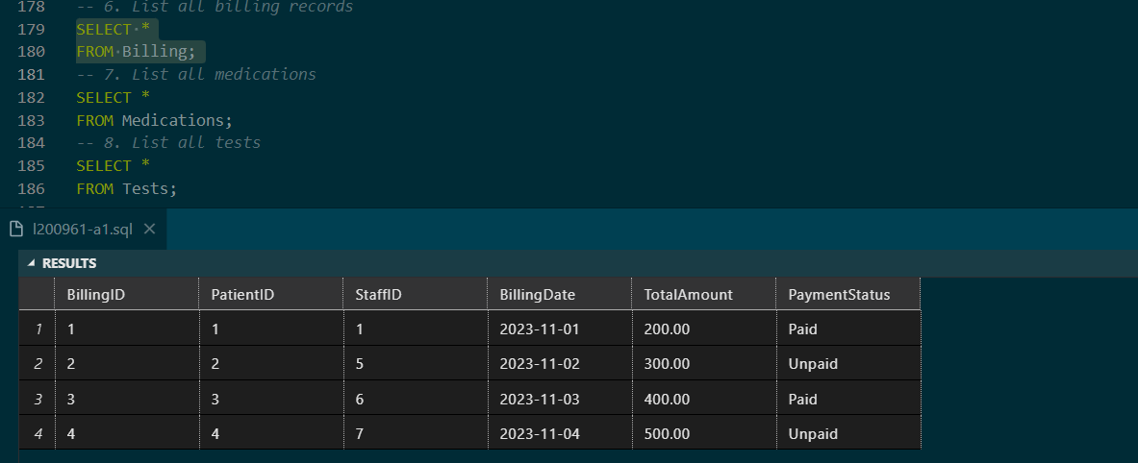
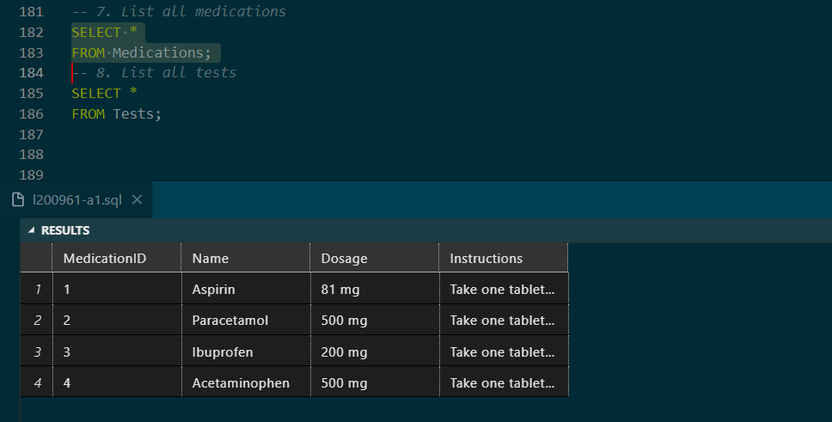
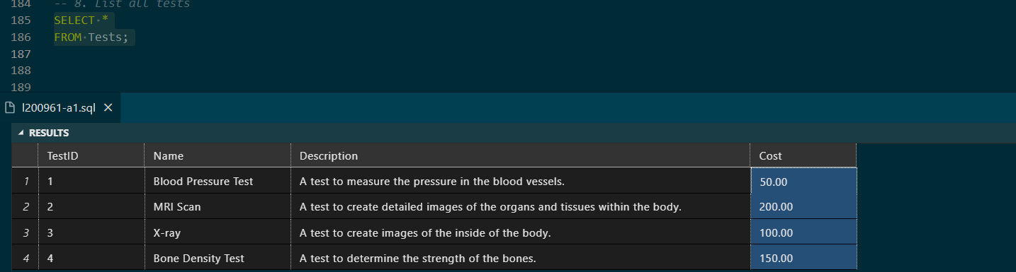
Outputs:
1. List female patients whose contact number ends with 5 or 6 and were treated by
“dr.sarah” 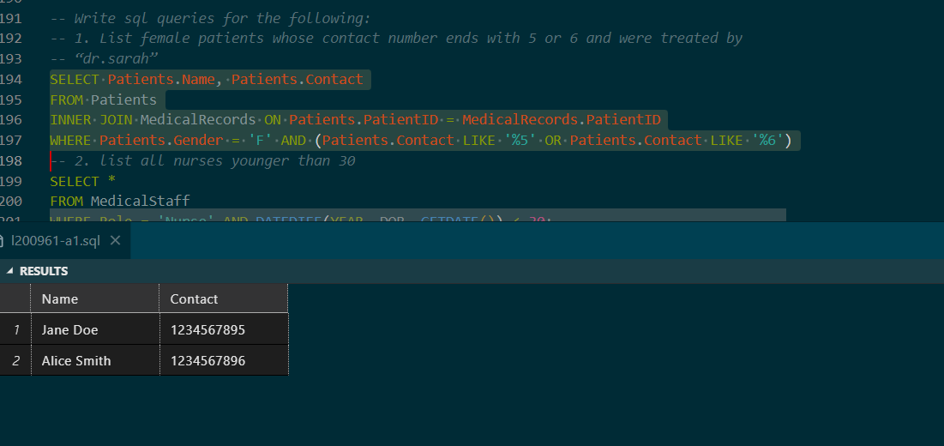
2. list all nurses younger than 30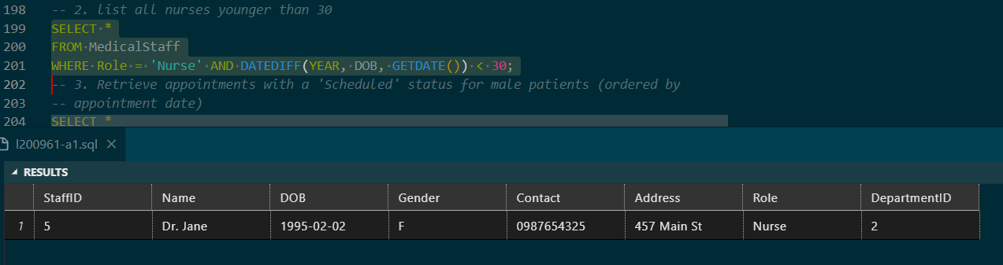
3. Retrieve appointments with a “Scheduled” status for male patients (ordered by
appointment date) 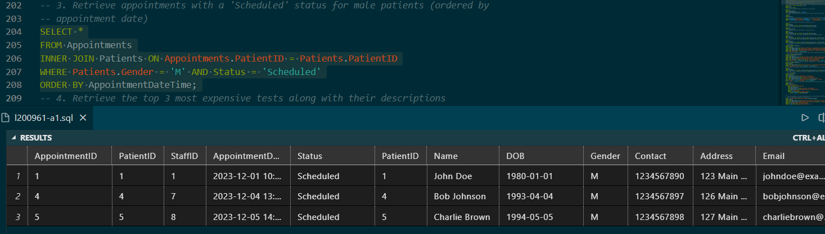
4. Retrieve the top 3 most expensive tests along with their descriptions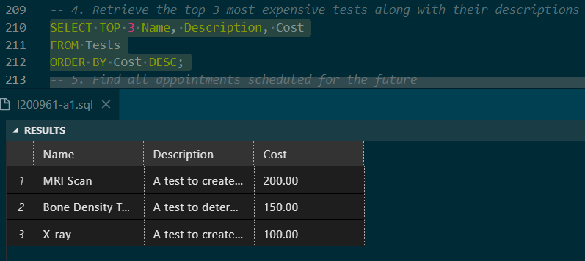
5. Find all appointments scheduled for the future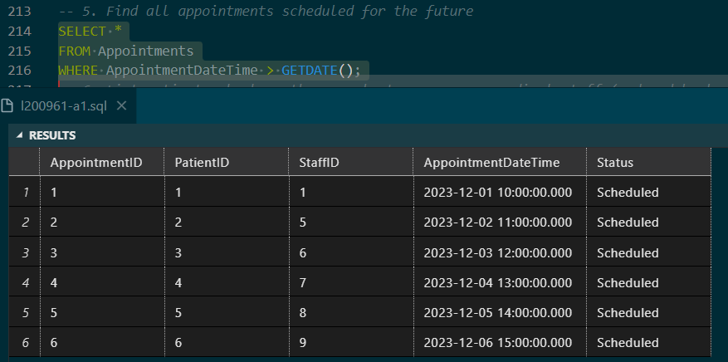
6. List patients who have the same last name as any medical staff (ordered by last
name) 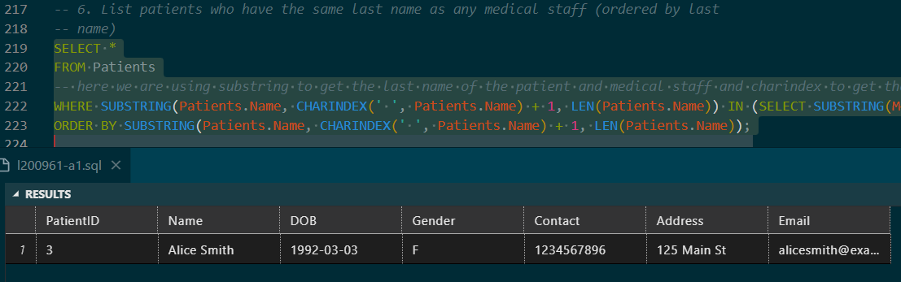
comments: Alice Smith and Dr.Smith.
7. Identify Patients Who Haven’t Received a Bill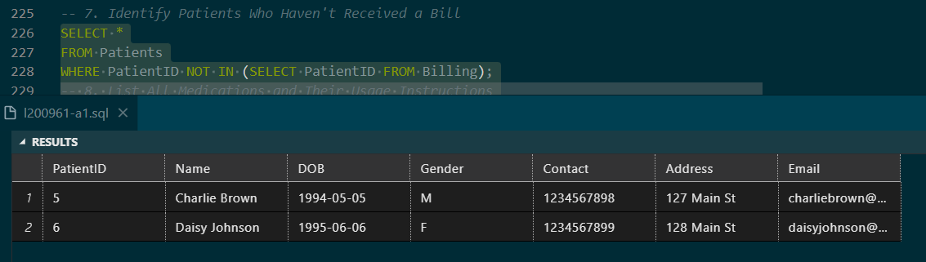
8. List All Medications and Their Usage Instructions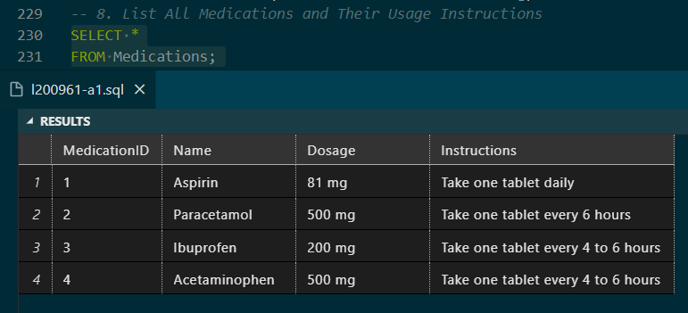
9. Identify Patients Who Haven’t Received a Bill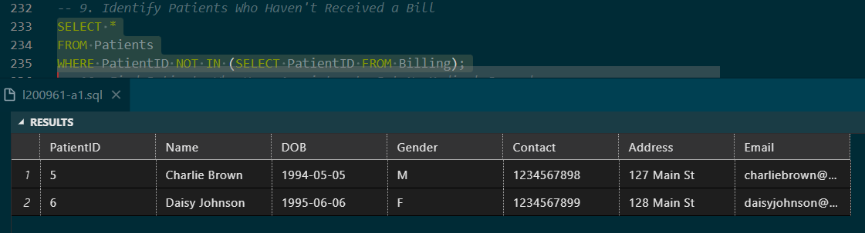
10. Find Patients Who Have Appointments But No Medical Records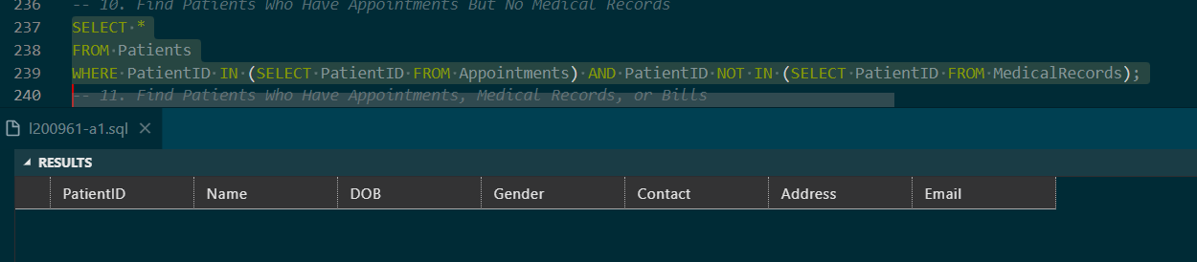
Comment: all patients have medical records for now.
11. Find Patients Who Have Appointments, Medical Records, or Bills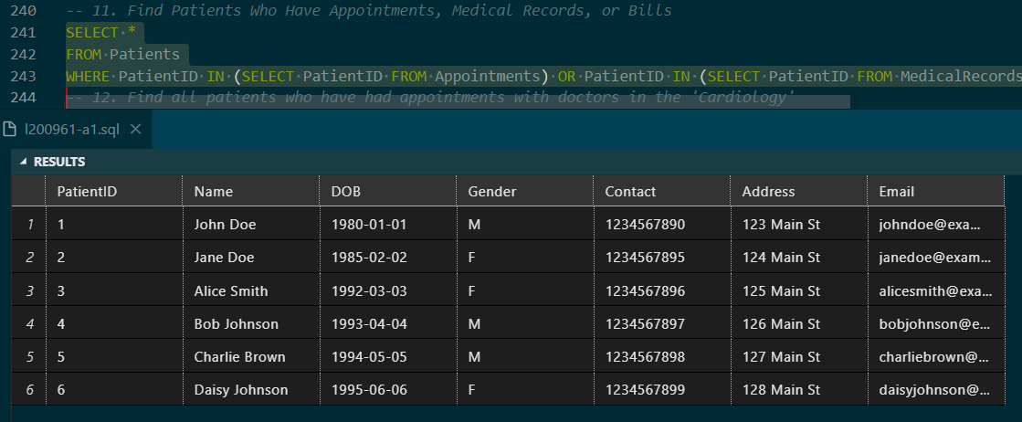
12. Find all patients who have had appointments with doctors in the ‘Cardiology’
department. 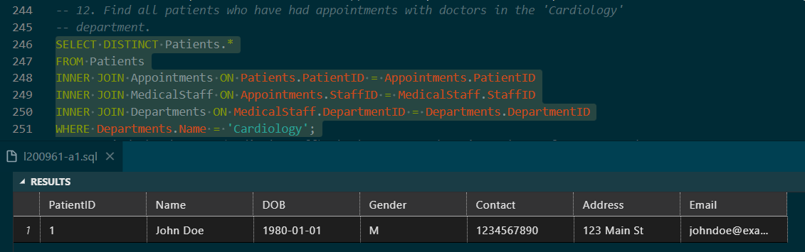
13. Find the doctors (medical staff) who have treated patients born after 1990 and
have ‘Paid’ billing status. 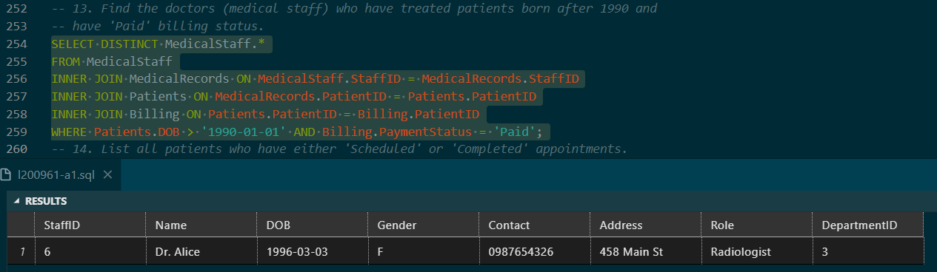
14. List all patients who have either ‘Scheduled’ or ‘Completed’ appointments. 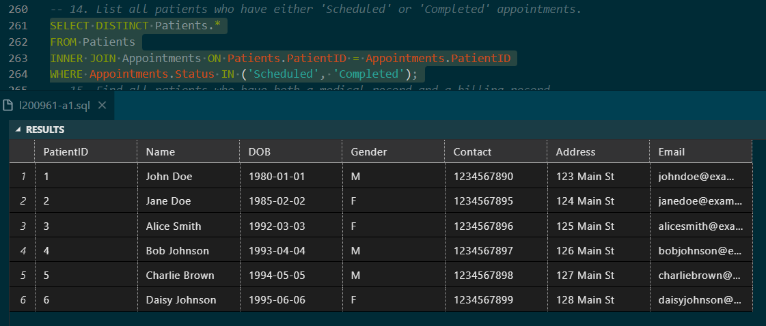
15. Find all patients who have both a medical record and a billing record. 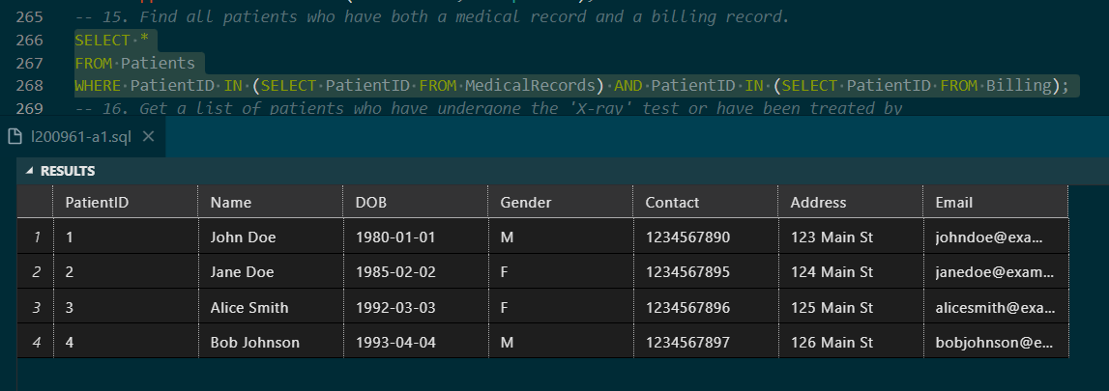
16. Get a list of patients who have undergone the ‘X-ray’ test or have been treated by
‘Dr. Lisa Wang’. 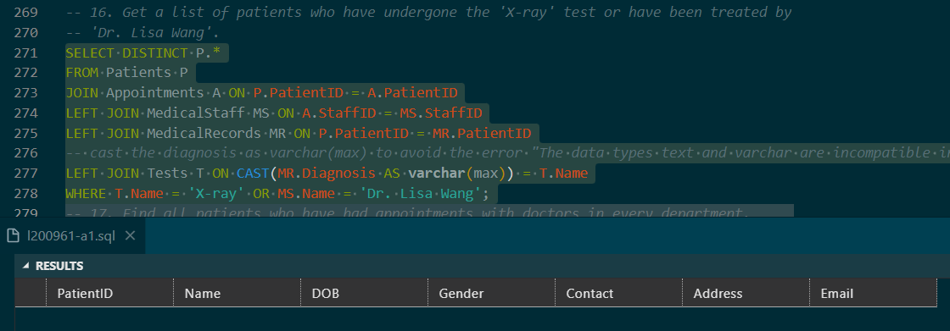
Comment: no patient had x-ray diagnosis and no patient was treated by dr. lisa wang.
17. Find all patients who have had appointments with doctors in every department. 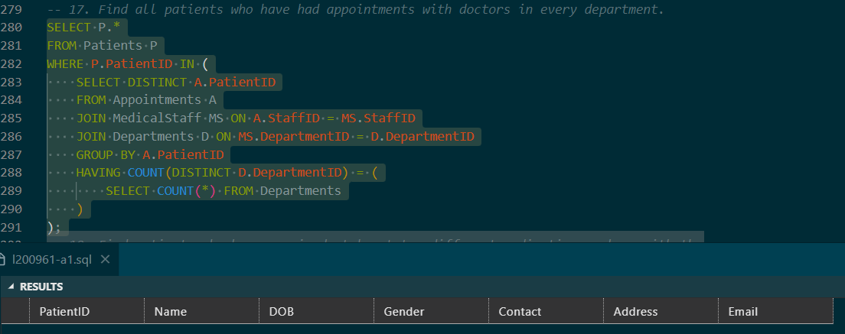
Comment: no patient appeared more than once in my inserted data, so no results appeared.
18. Find patients who have received at least two different medications, along with the
list of medications they have received. 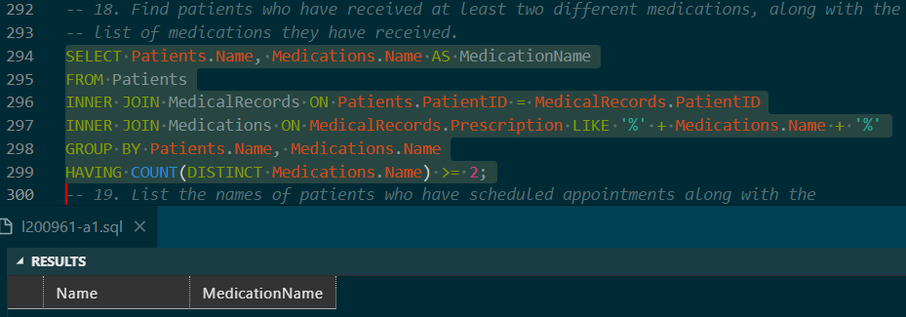
comment: prescriptions were not available for the data that I inserted, so no results were available.
19. List the names of patients who have scheduled appointments along with the
department they are associated with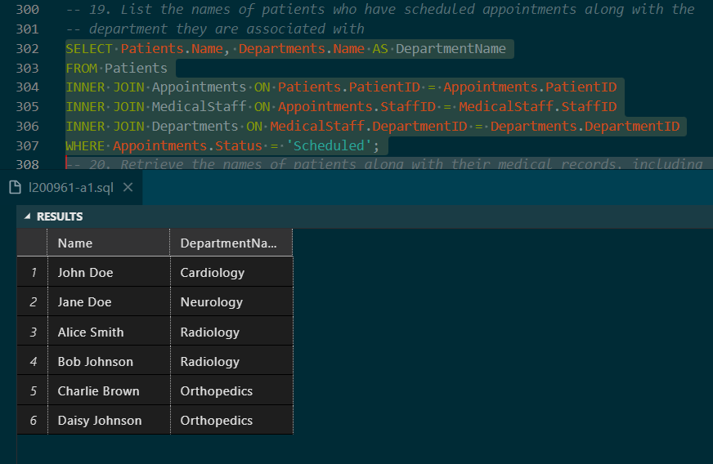
20. Retrieve the names of patients along with their medical records, including
diagnosis and treatment, and the names of the doctors who treated them